


Data Compliance Test (DCT)
Test Cases for
Adverse Drug Reaction (Chinese Medicine System) Record

<HCP Name>
Table of Contents
1 Testing Instructions to HCPs 3
1.1 Self-Service Testing Phase 3
1.2 Final Testing Phase 3
1.3 Preparation DCT Test Report 4
2 Test Case Details 5
CMADR-001 5
CMADR-002 12
3 Appendix – Sample Messages 16
4 Appendix – Testing HCP and HCRs Information 18
5 Appendix – Sample Results in eHR Viewer (EVE) 19
6 Appendix – Actual Data Values (Sample) 22

Testing Instructions to HCPs

Self-Service Testing Phase
- After development of the data upload programmes, you can use the Self-Service test accounts and test HCRs provided by eHealth for connection to the eHealth testing environment and proceed with the self-service testing.
- You can proceed with the Self-service test at your own pace by following this Self-Service Testing Guide and using the test cases provided in section 2.
- You can verify the correctness and completeness of the data upload by:
  - checking the interface files / messages generated in your system against the sample expected results of interface files /messages for all test cases as provided;
  - checking the results on eHR Viewer (EVE) by logging into the testing eHealth with the provided test account; and
  - checking the upload status through Process Summary and Exception Report in eHR Inbox by logging into the testing eHealth.
- For data fields requiring eHR Codex values, you can refer the Code Sets provided with the Self-Service Kit.
- For details of technical requirements of the data interface files, please refer to the ‘Developers’ Quick Guide for Adverse Drug Reaction (Chinese Medicine System) Data Upload to eHealth.docx’.
- You are required to perform the test cases that are relevant to the data compliance level supported by your clinic.
- You are required to perform the first batch of data upload by Data Materialization (DM) mode. DM mode is denoted in the interface by a fixed value BL-M in HL7 OBX.4
- You should use Incremental Load (INC) mode for the second batch of data upload to update the previously uploaded records. INC mode is denoted in the interface by a fixed value BL in HL7 OBX.4.
- Since the DM mode would replace the corresponding records previously uploaded to eHealth, you may repeat your testing unlimited number of times by uploading the first batch by DM mode.
- It should be noted that the data field “Record Key” should be unique for each Chinese medicines adverse drug reaction record, while each Chinese medicines adverse drug reaction record can carry multiple Chinese medicines adverse drug reaction causative agents.
- When all required test cases can be completed smoothly and correctly in this phase, you can proceed to the Final Testing Phase and submit production environment setup form to eHR DCT Support for preparation.

Final Testing Phase
- You can start the Final Testing Phase once all test cases in the Self-Service Testing phase are passed.
- You should start Final Test by executing the test cases provided in section 2 with Final Testing HCRs provided by eHR DCT Support.
- You can verify the correctness and completeness of testing results by checking results in eHR Viewer (EVE) and the upload status through Process Summary and Exception Report in eHR Inbox.
- For Adverse Drug Reaction DCT test cases, there are TWO batches of data files / transactions to be uploaded to the testing eHealth. The required records must be correctly uploaded from these 2 consecutive batches respectively.
- The Final Test will be considered PASSED if all the following criteria are met:
  - The TWO batches of test data files are uploaded consecutively in the correct sequence. The second batch of data files/transactions must be submitted after completion of processing of the first batch by eHealth.
  - No additional data files / transactions are uploaded in between or after the uploads of the above two batches of data files / transactions to amend any records.
  - No exception records are reported from the uploads.
  - No manual interventions have been made to the data files / transactions.
- If the Final Test failed, you can re-attempt the Self-Service Test and Final Test until a successful run can be completed.

Preparation DCT Test Report
- Once you have successfully passed the Final Test based on the above criteria, you should complete this document by attaching the below items to this document at the appropriate space provided:
  - Actual data files uploaded
  - Screen-shot of each test case
- You are required to submit this completed ‘DCT Test Cases’ document to eHR DCT Support for further processing. eHR DCT Support will provide feedback within 10 working days.

Test Case Details
1 | Test Case ID | CMADR-001
 | Function Description | HCP has received the sharing consents from testing HCRs, then perform first data upload of HCRs’ clinical records to eHealth by DM Mode.
 | Subsequent case of | N/A
 | Testing Assumption | - HCR1-HCR8 have already given sharing consent to your outpatient clinic.  - The eMR system (EMRS) will upload Batch 1 data files to eHealth with all Chinese medicines adverse drug reaction records of <HCR1> - <HCR8> created by DM mode.
 | Test Actions | HCP creates below Chinese Medicines adverse drug reaction records in eMR system:  For level 3 data, please perform test cases 1a – 1e  For level 2 data, please perform test cases 1f – 1h.
 | Test Actions | 1a | (Level 3 data) Input in the HCP’s EMRS a Chinese Medicines adverse drug reaction record ‘當歸’ with ‘噁心’ reaction for <HCR1>. The clinical record uploaded to eHealth should contain the follows:  - Chinese medicines adverse drug reaction causative agent - recognised terminology name = HKCTT  - Chinese medicines adverse drug reaction causative agent identifier - recognised terminology = 9800451  - Chinese medicines adverse drug reaction causative agent description - recognised terminology = 當歸  - Chinese medicines adverse drug reaction causative agent local code = (Optional)  - Chinese medicines adverse drug reaction causative agent local description = Description used in the EMRS e.g. 全當歸  - Level of severity code = S  - Level of severity description = Severe  - Level of severity local description = (Description used in the EMRS)  - Chinese medicines adverse drug reaction description = 噁心  - Chinese medicines adverse drug reaction causative agent remark = (Blank)  == Actual data values (Refer to “Appendix - Actual Data Values (Sample)” for details)
 | Test Actions | 1b | (Level 3 data) Input in the eMRS a Chinese medicines adverse drug reaction record ‘人參’ with ‘噁心’ reaction for <HCR2>. The clinical record uploaded to eHealth must contain the follows:  - Chinese medicines adverse drug reaction causative agent - recognised terminology name = HKCTT  - Chinese medicines adverse drug reaction causative agent identifier - recognised terminology = 9800035  - Chinese medicines adverse drug reaction causative agent description - recognised terminology = 人參  - Chinese medicines adverse drug reaction causative agent local code = (Optional)  - Chinese medicines adverse drug reaction causative agent local description = Description used in the EMRS e.g. 生晒人參  Please provide below optional data field(s) (if applicable)  - Level of severity code = NS  - Level of severity description = Non-severe  - Level of severity local description = (Description used in the EMRS)  - Chinese medicines adverse drug reaction description = 噁心  == Actual data values (Refer to “Appendix - Actual Data Values (Sample)” for details)
 | Test Actions | 1c | (Level 3 data) Input in the eMRS a Chinese medicines adverse drug reaction record ‘川芎’ with “瘙癢” reaction for <HCR3>. The clinical record uploaded to eHealth must contain the follows.  - Chinese medicines adverse drug reaction causative agent - recognised terminology name = HKCTT  - Chinese medicines adverse drug reaction causative agent identifier - recognised terminology = 9812345  - Chinese medicines adverse drug reaction causative agent description - recognised terminology = 川芎  - Chinese medicines adverse drug reaction causative agent local code = (Optional)  - Chinese medicines adverse drug reaction causative agent local description = 川芎  - Level of severity code = NS  - Level of severity description = Non-Severe  - Level of severity local description = (Description used in the EMRS)  - Chinese medicines adverse drug reaction description = 瘙癢  - Chinese medicines adverse drug reaction causative agent remark = 全身瘙癢  == Actual data values (Refer to “Appendix - Actual Data Values (Sample)” for details)  Remark: Chinese medicines adverse drug reaction causative agent remark would be shown when mouse-over the “i” button (i.e. information button). Screen capture of showing the remark is required.
 | Test Actions | 1d | (Level 3 data) Input in the eMRS an invalid recognised terminology for <HCR4>: a Chinese medicines adverse drug reaction record ‘白芍’ with ‘嘔吐’ reaction. The incorrect recognised description highlighted in RED below should be set up (override the correct description) in the eMRS beforehand just for this test case and should be reverted to the correct description afterwards. The clinical record uploaded to eHealth would contain the follows:  - Chinese medicines adverse drug reaction causative agent - recognised terminology name = HKCTT  - Chinese medicines adverse drug reaction causative agent identifier - recognised terminology = 9800126  - Chinese medicines adverse drug reaction causative agent description - recognised terminology = 白芍123  - Chinese medicines adverse drug reaction causative agent local code = (Optional)  - Chinese medicines adverse drug reaction causative agent local description = Description used in the eMRS e.g. 芍藥  Please provide below optional data field(s) (if applicable)  - Level of severity code = S  - Level of severity description = Severe  - Level of severity local description = (Description used in the eMRS)  - Adverse drug reaction description = 嘔吐  == Actual data values (Refer to “Appendix - Actual Data Values (Sample)” for details)  Remark: Since the Chinese medicines adverse drug reaction causative agent recognized terminology description is not matched with the one in HKCTT, this record will be re-graded to level 2 adverse drug reaction record and expected to be found in re-grade report.
 | Test Actions | 1e | (Level 3 data) Input in the eMRS a free-text Chinese medicines adverse drug reaction record ‘測試中藥’ with ‘嘔吐’ reaction for <HCR5>. The clinical record uploaded to eHealth must contain the follows:  - Chinese medicines adverse drug reaction causative agent local code = (Optional)  - Chinese medicines adverse drug reaction causative agent local description = 測試中藥  Please provide below optional data field(s) (if applicable)  - Level of severity code = S  - Level of severity description = Severe  - Level of severity local description = (Description used in the eMRS)  - Adverse drug reaction description = 嘔吐  == Actual data values (Refer to “Appendix - Actual Data Values (Sample)” for details)  Remark: Record will be shown in “Re-grade Report” as Chinese medicines adverse drug reaction causative agent - recognised terminology data fields are blank.
 | Test Actions | 1f | (Level 2 data) Input in the eMRS a free-text Chinese medicines adverse drug reaction record without recognised terminology for <HCR6>: a Chinese medicines adverse drug reaction ‘測試中藥’ with ‘嘔吐’ reaction. The clinical record uploaded to eHealth would contain the follows:  - Chinese medicines adverse drug reaction causative agent local code = (Optional)  - Chinese medicines adverse drug reaction causative agent local description = 測試中藥  - Level of severity local description = (Description used in the eMRS)  - Chinese medicines adverse drug reaction description = 嘔吐  == Actual data values (Refer to “Appendix - Actual Data Values (Sample)” for details)
 | Test Actions | 1g | (Level 2 data) Input in the eMRS a Chinese medicines adverse drug reaction record without recognised terminology for <HCR7>. A Chinese medicines adverse drug reaction to ‘田七’ with ‘嘔吐’ reaction. The clinical record uploaded to eHealth would contain the follows  - Chinese medicines adverse drug reaction causative agent local code = (Optional)  - Chinese medicines adverse drug reaction causative agent local description = 田七  - Level of severity local description = (Description used in the eMRS)  - Chinese medicines adverse drug reaction description = 嘔吐  - Chinese medicines adverse drug reaction causative agent remark = 嘔吐三天  == Actual data values (Refer to “Appendix - Actual Data Values (Sample)” for details)  Remark: Chinese medicines adverse drug reaction causative agent remark would be shown when mouse-over the “i” button (i.e. information button). Screen capture of showing the remark is required.
 | Test Actions | 1h | (Level 2 data) Input in the eMRS a Chinese medicines adverse drug reaction record without recognised terminology for <HCR8>. A Chinese medicines adverse drug reaction to ‘杏仁’ with ‘矢氣’ reaction. The clinical record uploaded to eHealth would contain the follows:  - Chinese medicines adverse drug reaction causative agent local code= (Optional)  - Chinese medicines adverse drug reaction causative agent local description = 杏仁  - Level of severity local description = (Description used in the eMRS)  - Chinese medicines adverse drug reaction description = 矢氣  == Actual data values (Refer to “Appendix - Actual Data Values (Sample)” for details)
 | Expected eMR System Behavior | - (Level 3 data) HCP’s eMR system will upload Batch 1 data files with all CMADR records of created in 1a-1e by DM mode.  - (Level 2 data) HCP’s eMR system will upload Batch 1 data files with all CMADR records of created in 1f-1h by DM mode.  - Batch 1 data files should include below files: <samples>  - Participant List (PL)  - Data File (DF)  - HL7 message with signature  - Zip File (embedded PL, DF and HL7 message files)  - Zip Control File (contains the filenames of PL, DF and HL7 message)  - eMR system uploads Batch 1 data files (‘Zip File’ and ‘Zip Control File') to eHealth.  - HCP verifies the data upload status by reviewing the 'Process Summary Report' and 'Exception Report' in eHR Inbox.  - HCP verifies the completeness and correctness of data uploaded in eHR Viewer.
 | Results Verification | - HCP verifies if the uploaded records can be properly viewed in eHR Viewer (EVE) and reviews if the data batches uploaded can be processed successfully or rejected through ‘Process Summary’, ‘Exception Report’ and ‘Re-grade Report’ in eHR Inbox.
 | Actual Result  (Screenshot / Attachment) | Data Files Uploaded:  <Attached the Zip file and Control file; password to unzip the file>
 | Actual Result  (Screenshot / Attachment) | Attachment/Screenshot:  <Attached the screen shots of records uploaded in eHR Viewers>
 | Remark | <State your reasons/ justification for exemption with case number>
 | Testing Date | <Provided by HCP>
 | Verified By | <Provided by HCP>

2 | Test Case ID | CMADR-002
 | Function Description | There are subsequent changes in HCRs’ clinical records in Batch 1 data upload. HCP uploads increment changes to eHealth by INC Mode.
 | Subsequent case of | CMADR-001
 | Testing Assumption | - HCP has already verified that Batch 1 data has been completed successfully.
 | Test Actions | HCP updates below CMADR records in eMR system (EMRS):  For level 3 data, please perform test cases 2a – 2d.  For level 2 data, please perform test cases 2e – 2g.
 | Test Actions | 2a | (Level 3 data) Add in eMRS Chinese medicines adverse drug reaction causative agent remark for  <HCR1> to test case 1(a) above as follows:  - (Add) Chinese medicines adverse drug reaction causative agent remark =噁心三日  == Actual data values (Refer to “Appendix - Actual Data Values (Sample)” for details)
 | Test Actions | 2b | (Level 3 data) Update test case 1(c) for <HCR3> on level of severity code, Chinese medicines adverse drug reaction description, and Chinese medicines adverse drug reaction causative agent remark as follows:  - (Update) Level of severity code = S  - (Update) Level of severity description = Severe  - (Update) Level of severity local description = (Description used in the eMRS which is different from test case 1(c))  - (Update) Chinese medicines adverse drug reaction description= 皮疹  - (Update) Chinese medicines adverse drug reaction causative agent remark = 全身皮疹  == Actual data values (Refer to “Appendix - Actual Data Values (Sample)” for details)  Remark: Chinese medicines adverse drug reaction causative agent remark would be shown when mouse-over the “i” button (i.e. information button). Screen capture of showing the remark is required.
 | Test Actions | 2c | (Level 3 data) Input in the eMRS a Chinese medicines adverse drug reaction causative agent named 大黃 with ‘咯血’ reaction for <HCR4>. The clinical record uploaded to eHealth should contain the follows:  - (Add) Chinese medicines adverse drug reaction causative agent - recognised terminology name = HKCTT  - (Add) Chinese medicines adverse drug reaction causative agent identifier - recognised terminology = 9800066  - (Add) Chinese medicines adverse drug reaction causative agent description - recognised terminology = 大黃  - (Add) Chinese medicines adverse drug reaction causative agent local code = (Optional)  - (Add) Chinese medicines adverse drug reaction causative agent local description = Description used in the eMRS  - (Add) Level of severity code = S  - (Add) Level of severity description = Severe  - (Add) Level of severity local description = (Description used in the eMRS)  - (Add) Chinese medicines Adverse drug reaction description = 咯血  == Actual data values (Refer to “Appendix - Actual Data Values (Sample)” for details)
 | Test Actions | 2d | (Level 3 data) Delete in eMRS the incorrect Chinese medicines adverse drug reaction record in test case 1(e) for <HCR5> uploaded in Batch 1 as follows:  Delete Chinese medicines adverse drug reaction reason = 錯誤輸入  == Actual data values (Refer to “Appendix - Actual Data Values (Sample)” for details)
 | Test Actions | 2e | (Level 2 data) <HCR6> reported that he/she also has severe Chinese medicines adverse drug reaction to ‘測試中藥2’. It will cause ”便血”  - (Add) Chinese medicines adverse drug reaction causative agent local code = (Optional)  - (Add) Chinese medicines adverse drug reaction causative agent local description =測試中藥2  - (Add) Level of severity local description = (Description used in the eMRS)  - (Add) Chinese medicines adverse drug reaction description = 便血  == Actual data values (Refer to “Appendix - Actual Data Values (Sample)” for details)
 | Test Actions | 2f | (Level 2 data) Update level of severity, Chinese medicines adverse drug reaction, and Chinese medicines adverse drug reaction causative agent remark of test case 1(g) for <HCR7> as follows:  - (Update) Level of severity local description = (Description used in the eMRS)  - (Update) Chinese medicines adverse drug reaction description = 咯血  - (Update) Chinese medicines adverse drug reaction causative agent remark = 咯血一週  == Actual data values (Refer to “Appendix - Actual Data Values (Sample)” for details)  Remark: Chinese medicines adverse drug reaction causative agent remark would be shown when mouse-over the “i” button (i.e. information button). Screen capture of showing the remark is required.
 |  | 2g | (Level 2 data) Delete in eMRS the incorrect Chinese medicines adverse drug reaction record in test case 1(h) for <HCR8> as follows:  - Delete Chinese medicines adverse drug reaction causative agent reason = 錯誤輸入  == Actual data values (Refer to “Appendix - Actual Data Values (Sample)” for details)
 | Expected eMR System Behavior | - (Level 3 data) HCP’s eMR system generated Batch 2 INC data file with items 2a-2d transactions to eHealth.  - (Level 2 data) HCP’s eMR system generated Batch 2 INC data file with items 2e-2g transactions to eHealth.  - Batch 2 data files should include below files: <samples>  - Participant List (PL)  - Data File (DF)  - HL7 message with signature  - Zip File (embedded PL, DF and HL7 message files)  - Zip Control File (contains the filenames of PL, DF and HL7 message)  - eMR system uploads Batch 2 data files (‘Zip File’ and ‘Zip Control File') to eHealth.  - HCP verifies the data upload status by reviewing the 'Process Summary Report' and 'Exception Report' in eHR Inbox.  - HCP verifies the completeness and correctness of data uploaded in eHR Viewer.
 | Results Verification | - HCP verifies if the uploaded records can be properly viewed in eHR Viewer (EVE) and reviews if the data batches uploaded can be processed successfully or rejected through ‘Process Summary’, ‘Exception Report’ and ‘Re-grade Report’ in eHR Inbox.
 | Actual Result  (Screenshot / Attachment) | Data Files Uploaded:  <Attached the Zip file and Control file; password to unzip the file>
 | Actual Result  (Screenshot / Attachment) | Attachment/Screenshot:  <Attached the screen shots of records uploaded in eHR Viewers>
 | Remark | <State your reasons/ justification for exemption with case number>
 | Testing Date | <Provided by HCP>
 | Verified By | <Provided by HCP>

Appendix – Sample Messages
Test Case ID | Step No. | File Type | Bulk Load Format | SOAP Format  (by LAAM)
CMADR-001 | 1a – 1e | Participant List (PL)
CMADR-001 | 1a – 1e | Data File (DF)
CMADR-001 | 1a – 1e | HL7 Message
CMADR-001 | 1a – 1e | Zip File | (Password: Abcd1234)
CMADR-001 | 1a – 1e | Control File
CMADR-001 | 1f – 1h | Participant List (PL)
CMADR-001 | 1f – 1h | Data File (DF)
CMADR-001 | 1f – 1h | HL7 Message
CMADR-001 | 1f – 1h | Zip File | (Password: Abcd1234)
CMADR-001 | 1f – 1h | Control File
CMADR-002 | 2a – 2d | Participant List (PL)
CMADR-002 | 2a – 2d | Data File (DF)
CMADR-002 | 2a – 2d | HL7 Message
CMADR-002 | 2a – 2d | Zip File | (Password: Abcd1234)
CMADR-002 | 2a – 2d | Control File
CMADR-002 | 2e – 2g | Participant List (PL)
CMADR-002 | 2e – 2g | Data File (DF)
CMADR-002 | 2e – 2g | HL7 Message
CMADR-002 | 2e – 2g | Zip File | (Password: Abcd1234)
CMADR-002 | 2e – 2g | Control File

Appendix – Testing HCP and HCRs Information
Sample Message
Self-Service Testing | <Attach the testing HCRs excel file used>
Final Testing | <Attach the testing HCRs excel file used>

  - eHR DCT Support will provide other sets of testing HCRs for HCP to perform Self-Service testing and Final testing respectively.

Appendix – Sample Results in eHR Viewer (EVE)
  - After logging in eHR Viewer and selecting the HCR (the information of HCP is display in the left-hand corner of the top), click ‘Clinical’ in menu bar then choose ‘eHR Viewer’ or click ‘eHR Viewer’ under Clinical of Quick Links.

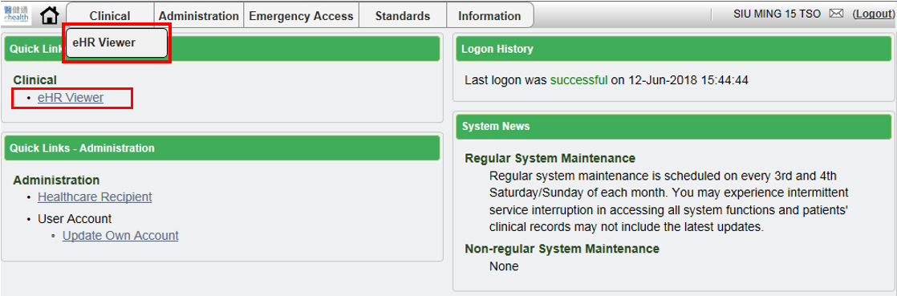

  - Adverse Drug Reaction summary is located on the top right-hand side which displaying ADR descriptions and information. Click ‘詳情’ or ‘>>更多’ to have details view of the records.

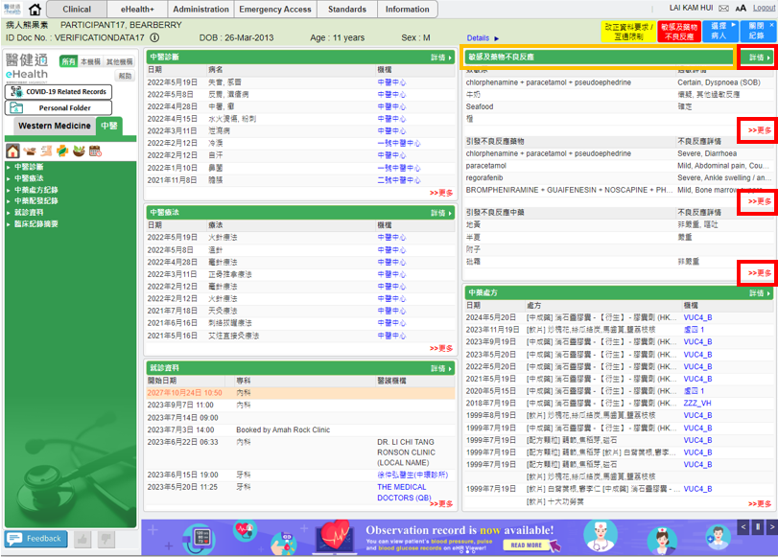
  - In below Detail View, records will be shown under ‘敏感及藥物不良反應詳情’ in right panel. It shows the 引發不良反應藥物, 不良反應詳情, 日期 and 機構. ‘引發不良反應藥物’ display Western Medicines ADR records while ‘引發不良反應中藥’ display Chinese Medicines ADR records.

  - Filtering for Non-Local HCP (所有/本機構/其他機構) will not be applied to CM ADR data.

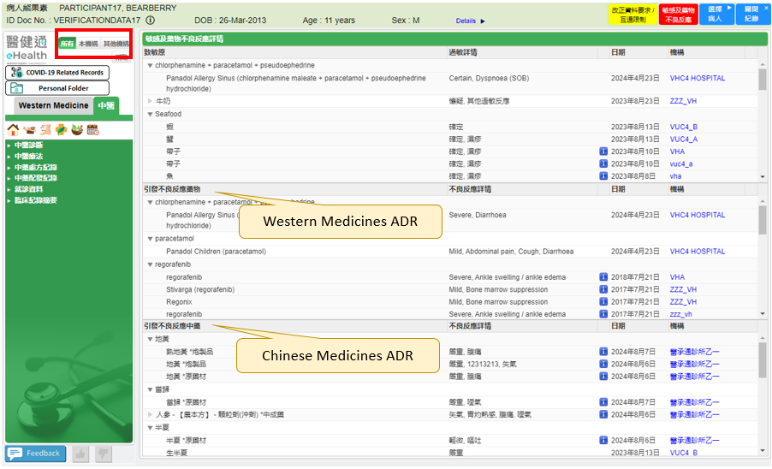

Contents in below columns:
 | ADR Causative Agent | ADR Information
Level 2 | Local Description of Chinese Medicines ADR Causative Agent (No Grouping) | Level of severity local description + “,” + Adverse drug reaction description
Level 3 | Group Chinese Medicines ADR causative agent by Chinese Materia Medica (CMM) term ID, display eHR description of CMM

where the default sorting sequence is:
      - Record last update date (reverse chronological) (last update date of record in source system in HCP)
      - Causative agent name
      - Institution name

Notations:
Expand arrow for Level 3 data
Dimmed arrow for Level 2 data
Display ADR causative agent remark after clicking it, no label would be shown when no data

Appendix – Actual Data Values (Sample)

If the actual values entered are various from the test case, please provide actual values as below.
If the value is not inputted, please use [BLANK] to indicate that empty value is inputted intentionally.

